**WEEK 7 REACT HANDS_ON EXERCISES**

**ReactJS-HOL Exercise 9:**

**ListofPlayers.js:**

import React from "react";

function ListofPlayers({ players }) {

  return (

    <div>

      {players.map((item, index) => (

        <div key={index}>

          <li>

            Mr. {item.name} <span>{item.score}</span>

          </li>

        </div>

      ))}

    </div>

  );

}

export default ListofPlayers;

**ScoreBelow70.js:**

import React from "react";

function ScoreBelow70({ players }) {

  const players70 = [];

  players.map((item) => {

    if (item.score < 70) {

      players70.push(item);

    }

    return null;

  });

  return (

    <div>

      {players70.map((item, index) => (

        <div key={index}>

          <li>

            Mr. {item.name} <span>{item.score}</span>

          </li>

        </div>

      ))}

    </div>

  );

}

export default ScoreBelow70;

**OddPlayers.js:**

import React from "react";

function OddPlayers({ IndianTeam }) {

  const [first, , third, , , fifth] = IndianTeam;

  return (

    <div>

      <li>First : {first}</li>

      <li>Third : {third}</li>

      <li>Fifth : {fifth}</li>

    </div>

  );

}

export default OddPlayers;

**EvenPlayers.js:**

import React from "react";

function EvenPlayers({ IndianTeam }) {

  const [, second, , fourth, , sixth] = IndianTeam;

  return (

    <div>

      <li>Second : {second}</li>

      <li>Fourth : {fourth}</li>

      <li>Sixth : {sixth}</li>

    </div>

  );

}

export default EvenPlayers;

**ListofIndianPlayers.js:**

import React from "react";

function ListofIndianPlayers({ IndianPlayers }) {

  return (

    <div>

      {IndianPlayers.map((player, index) => (

        <li key={index}>{player}</li>

      ))}

    </div>

  );

}

export default ListofIndianPlayers;

**App.js:**

import React from "react";

import ListofPlayers from "./ListofPlayers";

import Scorebelow70 from "./ScoreBelow70";

import OddPlayers from "./OddPlayers";

import EvenPlayers from "./EvenPlayers";

import ListofIndianPlayers from "./ListofIndianPlayers";

function App() {

  var flag = false;

  const players = [

    { name: "Jack", score: 50 },

    { name: "Michael", score: 70 },

    { name: "John", score: 40 },

    { name: "Ann", score: 61 },

    { name: "Elisabeth", score: 61 },

    { name: "Sachin", score: 95 },

    { name: "Dhoni", score: 100 },

    { name: "Virat", score: 84 },

    { name: "Jadeja", score: 64 },

    { name: "Raina", score: 75 },

    { name: "Rohit", score: 80 }

  ];

  const IndianTeam = ["Sachin1", "Dhoni2", "Virat3", "Rohit4", "Yuvraj5", "Raina6"];

  const T20Players = ["First Player", "Second Player", "Third Player"];

  const RanjiTrophyPlayers = ["Fourth Player", "Fifth Player", "Sixth Player"];

  const IndianPlayers = [...T20Players, ...RanjiTrophyPlayers];

  if (flag === true) {

    return (

      <div>

        <h1>List of Players</h1>

        <ListofPlayers players={players} />

        <hr />

        <h1>List of Players having Scores Less than 70</h1>

        <Scorebelow70 players={players} />

      </div>

    );

  } else {

    return (

      <div>

        <div>

          <h1>Indian Team</h1>

          <h1>Odd Players</h1>

          <OddPlayers IndianTeam={IndianTeam} />

          <hr />

          <h1>Even Players</h1>

          <EvenPlayers IndianTeam={IndianTeam} />

        </div>

        <hr />

        <h1>List of Indian Players Merged:</h1>

        <ListofIndianPlayers IndianPlayers={IndianPlayers} />

      </div>

    );

  }

}

export default App;

**OUTPUT:**

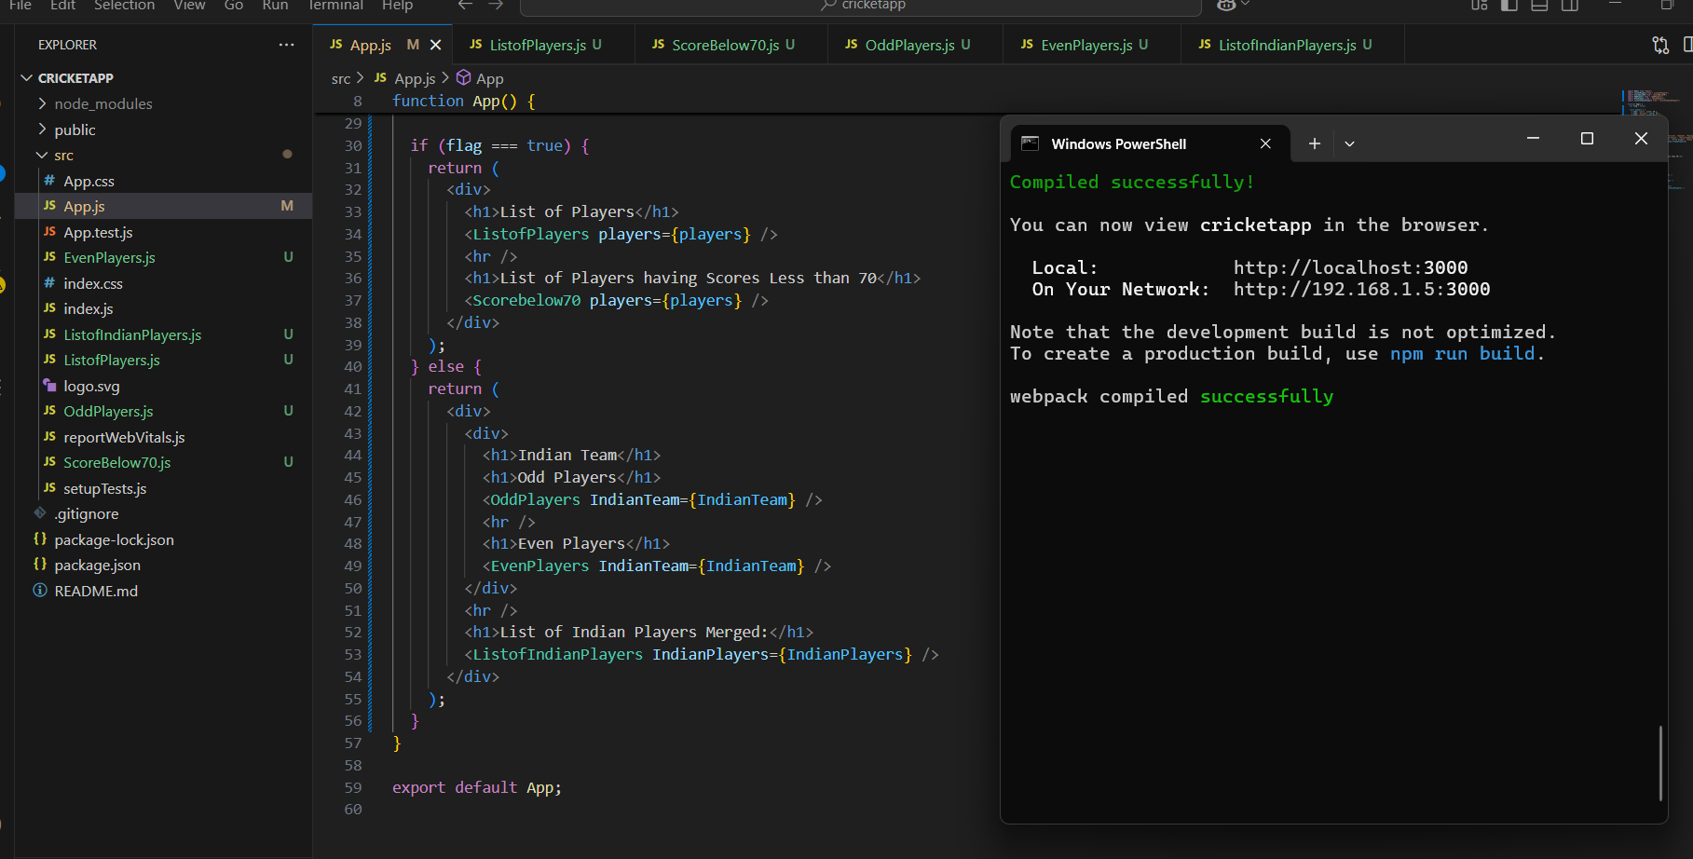

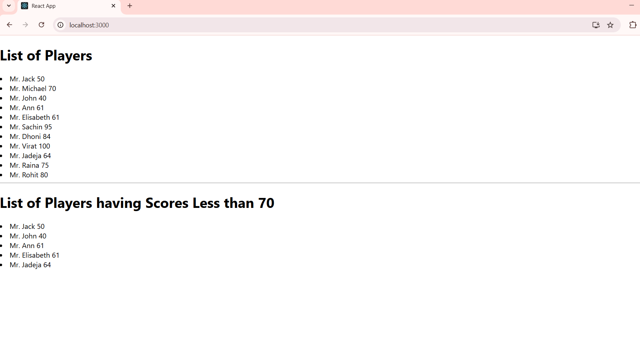**For TRUE:**

**For FALSE:**

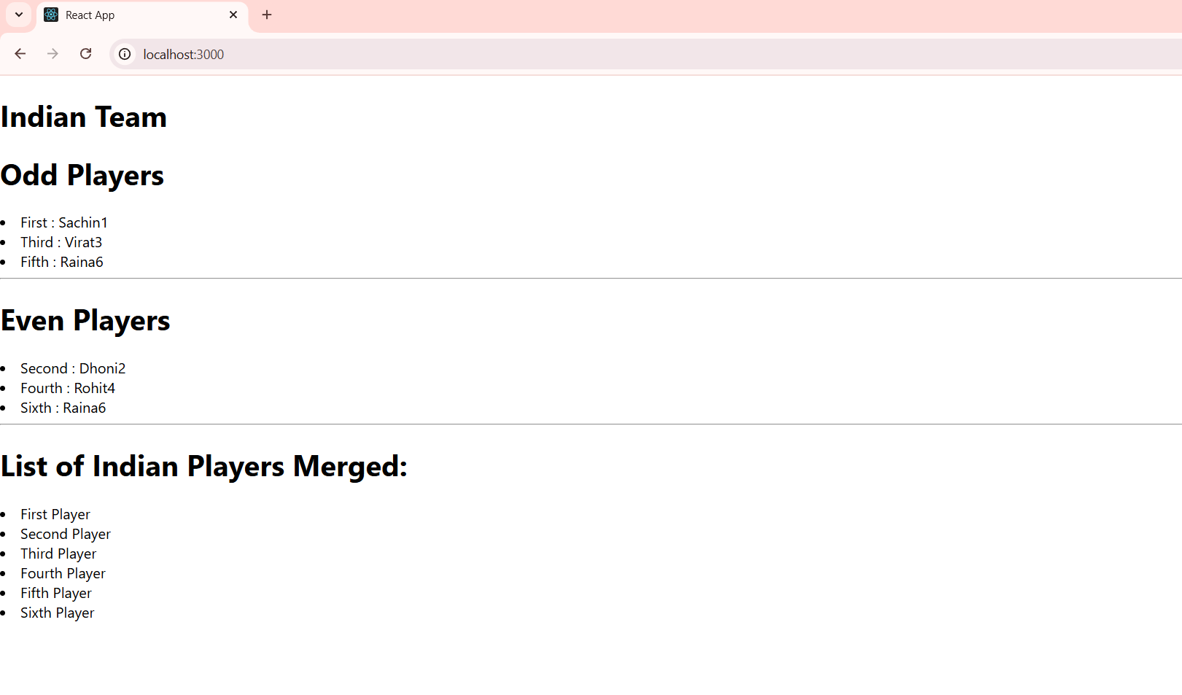

**ReactJS-HOL Exercise 10:**

**App.js:**

import React from 'react';

function App() {

  const officeList = [

    { Name: 'DBS', Rent: 50000, Address: 'Chennai', Image: 'https://t4.ftcdn.net/jpg/03/84/55/29/360_F_384552930_zPoe9zgmCF7qgt8fqSedcyJ6C6Ye3dFs.jpg' },

  ];

  const getRentColor = (rent) => {

    return {

      color: rent < 60000 ? 'red' : 'green'

    };

  };

  return (

    <div style={{ textAlign: 'center' }}>

      <h1>Office Space, at Affordable Range</h1>

      {officeList.map((item, index) => (

        <div key={index} style={{ margin: '20px 0' }}>

          <img src={item.Image} width="25%" height="25%" alt="Office Space" />

          <h3><strong>Name:</strong> {item.Name}</h3>

          <h3 style={getRentColor(item.Rent)}>Rent Rs. {item.Rent}</h3>

          <h3><strong>Address:</strong> {item.Address}</h3>

        </div>

      ))}

    </div>

  );

}

export default App;

**OUTPUT:**

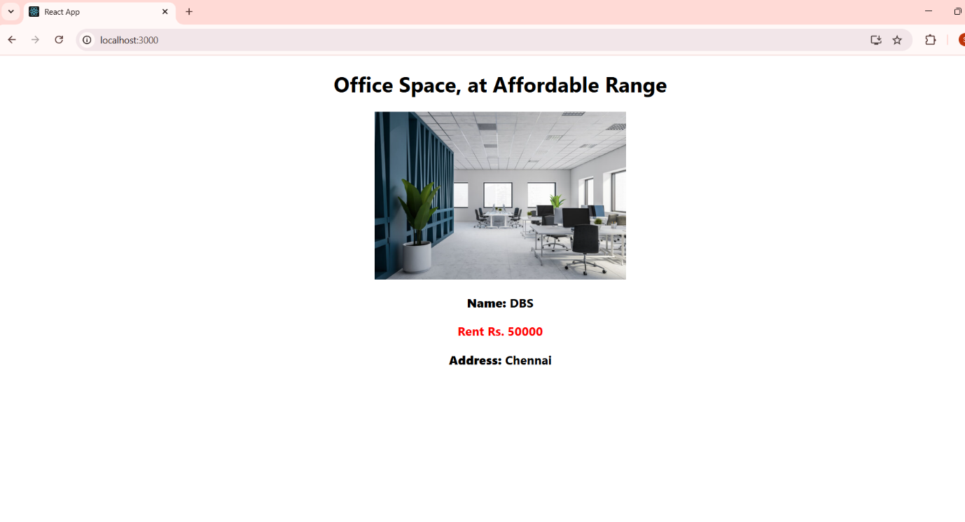

**ReactJS-HOL Exercise 11:**

**CurrencyConverter.js:**

import React, { Component } from 'react';

class CurrencyConvertor extends Component {

  constructor(props) {

    super(props);

    this.state = {

      rupees: '',

      currency: '',

    };

  }

  handleRupeesChange = (e) => {

    this.setState({ rupees: e.target.value });

  };

  handleCurrencyChange = (e) => {

    this.setState({ currency: e.target.value });

  };

  handleSubmit = (e) => {

    e.preventDefault();

    const { rupees, currency } = this.state;

    if (rupees === '' || currency === '') {

      alert('Please enter both amount and currency type.');

    } else {

      alert(`Converting to ${currency} amount is ${rupees}`);

    }

  };

  render() {

    return (

      <div>

        <h2 style={{ color: 'green', fontWeight: 'bold' }}>

          Currency Convertor!!!

        </h2>

        <form onSubmit={this.handleSubmit}>

          <label>Amount:</label>&nbsp;

          <input

            type="text"

            value={this.state.rupees}

            onChange={this.handleRupeesChange}

          />

          <br /><br />

          <label>Currency:</label>&nbsp;

          <input

            type="text"

            value={this.state.currency}

            onChange={this.handleCurrencyChange}

          />

          <br /><br />

          <button type="submit">Submit</button>

        </form>

      </div>

    );

  }

}

export default CurrencyConvertor;

**App.js:**

import React, { Component } from 'react';

import CurrencyConvertor from './CurrencyConvertor';

class App extends Component {

  constructor(props) {

    super(props);

    this.state = {

      count: 5,

    };

  }

  handleIncrement = () => {

    this.incrementCount();

    this.sayHello();

  };

  incrementCount = () => {

    this.setState({ count: this.state.count + 1 });

  };

  sayHello = () => {

    alert("Hello! Member1");

  };

  handleDecrement = () => {

    this.setState({ count: this.state.count - 1 });

  };

  sayWelcome = (message) => {

    alert(message);

  };

  handleClick = (e) => {

    alert("I was clicked");

  };

  render() {

    return (

      <div style={{ padding: '20px' }}>

        <div style={{ fontSize: '24px', marginBottom: '10px' }}>{this.state.count}</div>

        <button onClick={this.handleIncrement}>Increment</button> &nbsp;

        <button onClick={this.handleDecrement}>Decrement</button> &nbsp;

        <button onClick={() => this.sayWelcome("welcome")}>Say welcome</button> &nbsp;

        <button onClick={this.handleClick}>Click on me</button>

        <br /><br />

        <CurrencyConvertor />

      </div>

    );

  }

}

export default App;

**OUTPUT:**

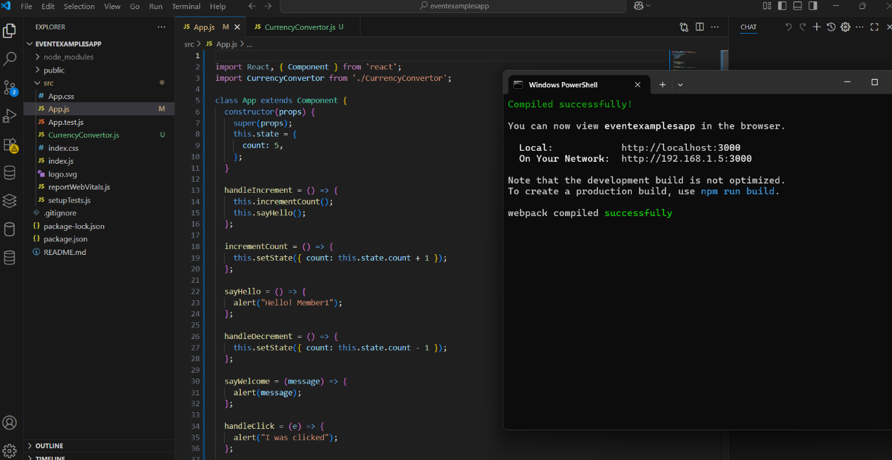

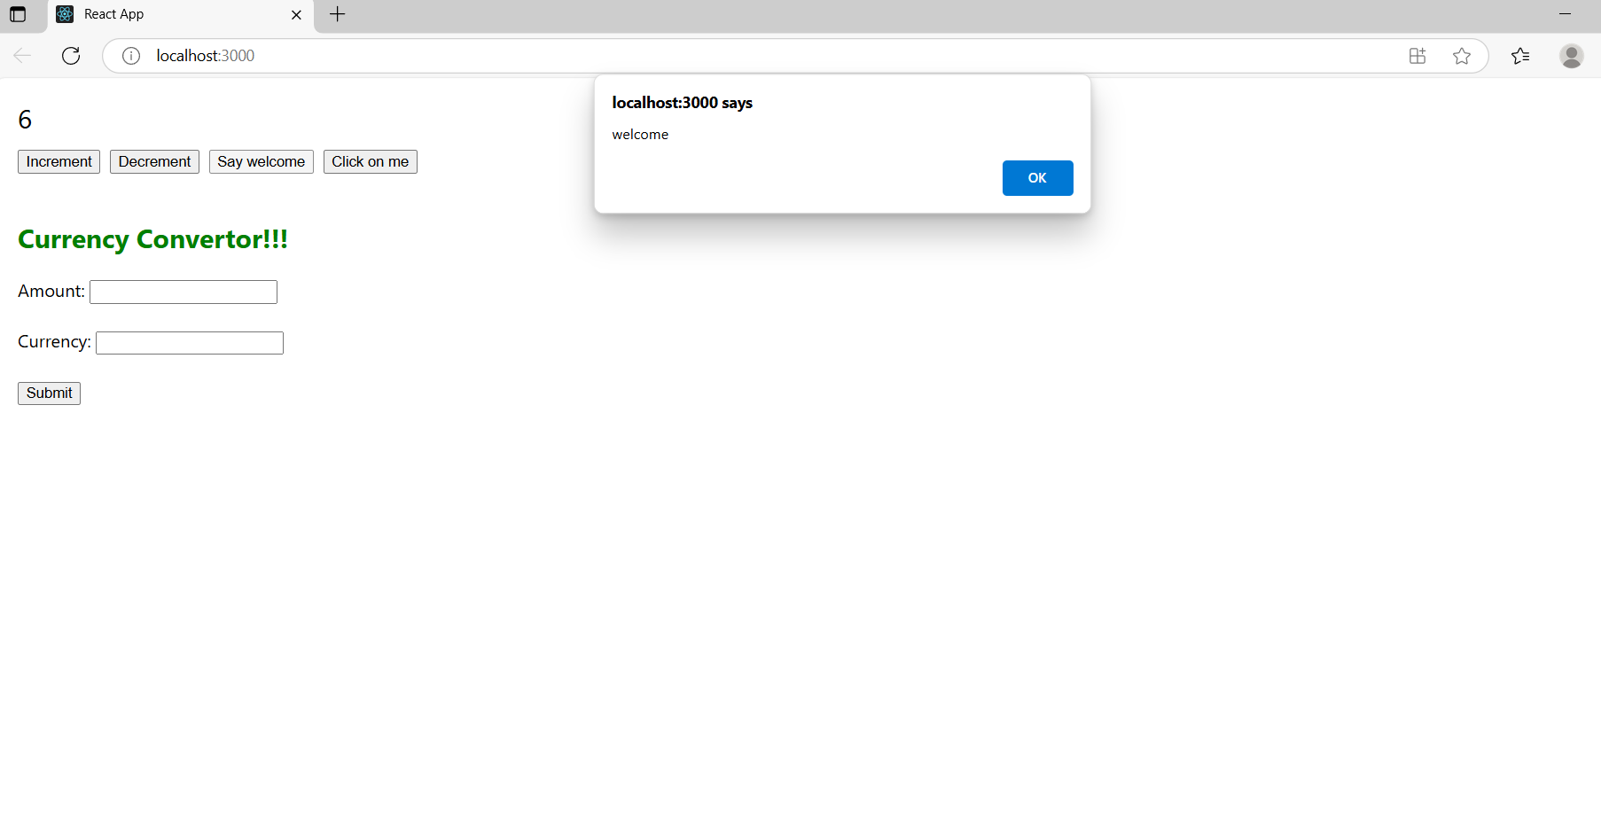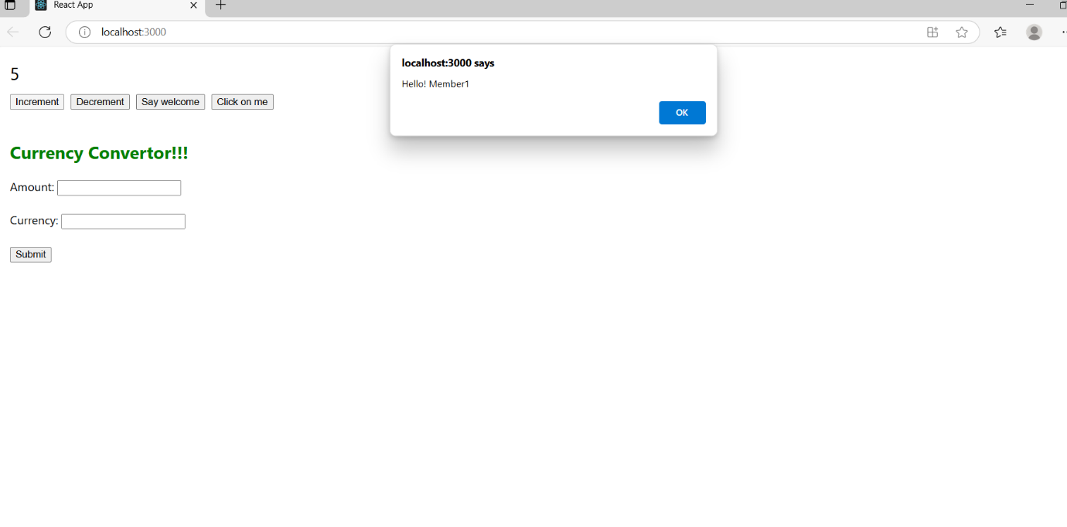

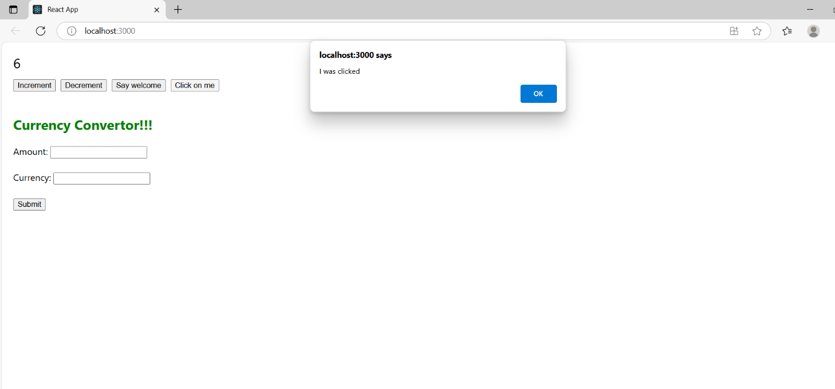

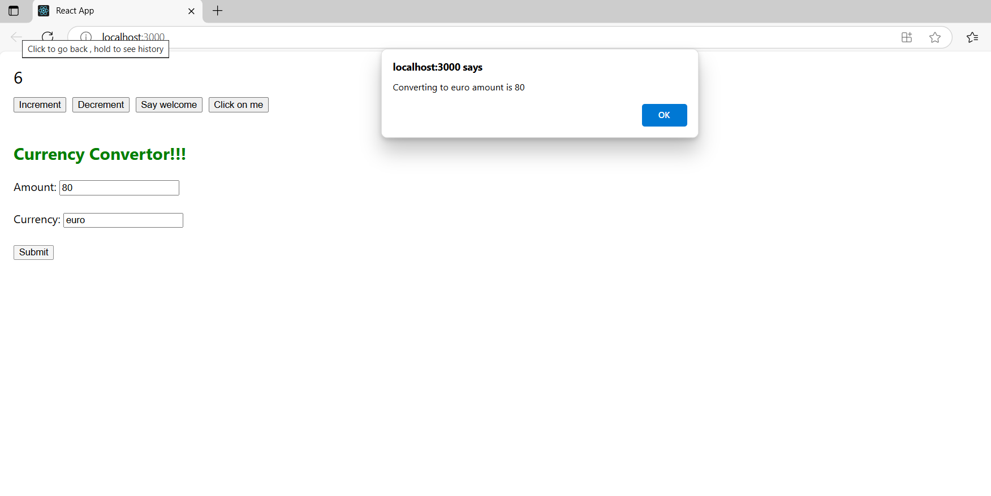

**ReactJS-HOL Exercise 12:**

**LoginControl.js:**

import React, { useState } from 'react';

function LoginButton(props) {

  return (

    <button onClick={props.onClick}>

      Login

    </button>

  );

}

function LogoutButton(props) {

  return (

    <button onClick={props.onClick}>

      Logout

    </button>

  );

}

function UserGreeting() {

  return <h2>Welcome back.</h2>;

}

function GuestGreeting() {

  return <h2>Please Sign Up.</h2>;

}

function Greeting(props) {

  const isLoggedIn = props.isLoggedIn;

  if (isLoggedIn) {

    return <UserGreeting />;

  }

  return <GuestGreeting />;

}

function LoginControl() {

  const [isLoggedIn, setIsLoggedIn] = useState(false);

  const handleLoginClick = () => {

    setIsLoggedIn(true);

  };

  const handleLogoutClick = () => {

    setIsLoggedIn(false);

  };

  let button;

  if (isLoggedIn) {

    button = <LogoutButton onClick={handleLogoutClick} />;

  } else {

    button = <LoginButton onClick={handleLoginClick} />;

  }

  return (

    <div>

      <Greeting isLoggedIn={isLoggedIn} />

      {button}

    </div>

  );

}

export default LoginControl;

**App.js:**

import React from 'react';

import './App.css';

import LoginControl from './LoginControl';

function App() {

  return (

    <div className="App">

      <h1>Flight Ticket Booking App</h1>

      <LoginControl /> {LoginControl}

    </div>

  );

}

export default App;

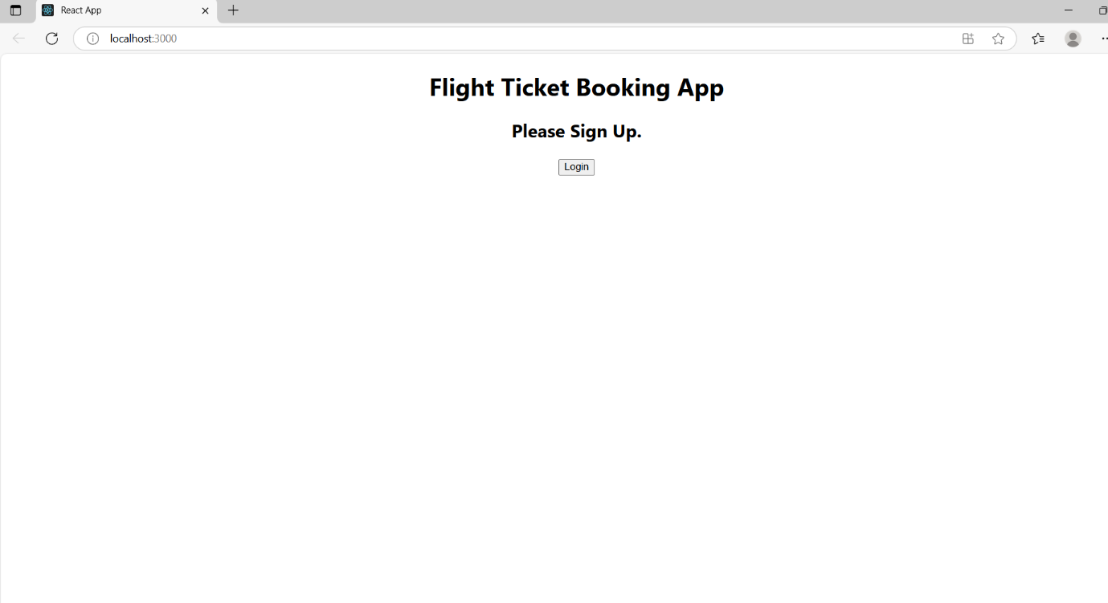**OUTPUT:**

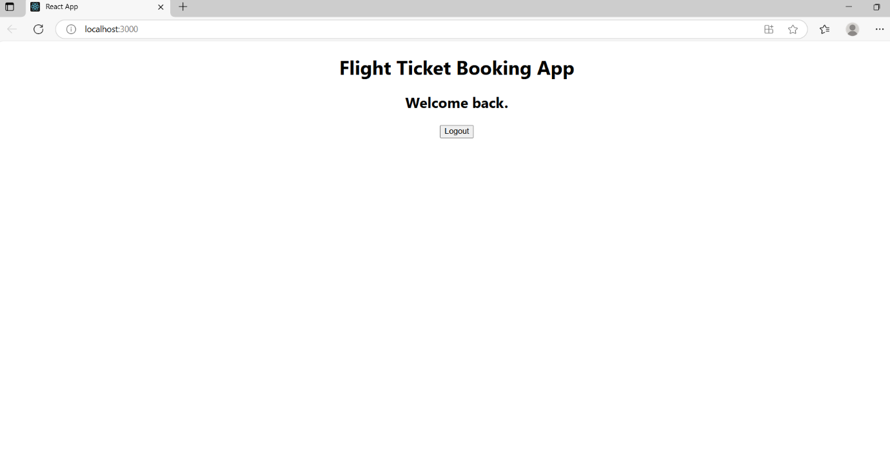

**ReactJS-HOL Exercise 13:**

**CourseDetails.js:**

function CourseDetails({ courses }) {

  return (

    <div className=".column">

      <h1>Course Details</h1>

      {courses.map((course) => (

        <div key={course.id}>

          <h3>{course.name}</h3>

          <p>{course.date}</p>

        </div>

      ))}

    </div>

  );

}

export default CourseDetails;

**BookDetails.js:**

function BookDetails({ books }) {

  return (

    <div className="column">

      <h2>Book Details</h2>

      {books.map((book) => (

        <div key={book.id}>

          <h3>{book.bname}</h3>

          <p>{book.price}</p>

        </div>

      ))}

    </div>

  );

}

export default BookDetails;

**bookData.js:**

export const books = [

  { id: 101, bname: 'Master React', price: 670 },

  { id: 102, bname: 'Deep Dive into Angular 11', price: 800 },

  { id: 103, bname: 'Mongo Essentials', price: 450 }

];

export const blogs = [

  { id: 201, title: 'React Learning', author: 'Stephen Biz' },

  { id: 202, title: 'Installation', author: 'Schwezdenier' }

];

export const courses = [

  { id: 301, name: 'Angular', date: '4/5/2021' },

  { id: 302, name: 'React', date: '6/3/2021' }

];

**BlogDetails.js:**

function BlogDetails({ blogs }) {

  return (

    <div className="column">

      <h2>Blog Details</h2>

      {blogs.map((blog) => (

        <div key={blog.id}>

          <h3>{blog.title}</h3>

          <p>{blog.author}</p>

        </div>

      ))}

    </div>

  );

}

export default BlogDetails;

**App.js:**

import React, { useState } from 'react';

import BookDetails from './components/BookDetails';

import BlogDetails from './components/BlogDetails';

import CourseDetails from './components/CourseDetails';

import { books, blogs, courses } from './data/bookData';

import './App.css';

function App() {

  const [view, setView] = useState('all');

  return (

    <div className="App">

      <h1 style={{ textAlign: 'center' }}></h1>

      <div className="container">

        {view === 'course' && <CourseDetails courses={courses} />}

        {view === 'book' && <BookDetails books={books} />}

        {view === 'blog' && <BlogDetails blogs={blogs} />}

        {view === 'all' && (

          <>

            <CourseDetails courses={courses} />

            <BookDetails books={books} />

            <BlogDetails blogs={blogs} />

          </>

        )}

      </div>

    </div>

  );

}

export default App;

**OUTPUT:**

